Evaluate and Make PDFs Accessible

1. Prepare

Understand Some of the Features of Adobe Acrobat Pro XI
Adobe Acrobat Pro XI is a program that allows you to save PDFs as editable Word, Excel and PowerPoint files, to make edits to text and images in PDF files, to create fillable PDF forms, to convert files scanned as images to HTML or Word using optical character recognition (OCR) plus much more. We will be using it today to check and repair accessibility issues in PDF documents.

Download and Review a Word Document
Go to the Instructional Services Website: http://ww2.nscc.edu/lyle_l and click on Accessibility. Under the heading “Files for March 25, 2015, Session – PDF”:
- Locate the “SyllabusTagged.docx” link.
- Right-click on the link and choose “Save target as” or similar wording depending on the browser (or click and open). This is a file with accessibility features that have been assigned in Microsoft Word.
- Review the document to ensure that image alt text, headings, lists, table row header, and links are properly formatted.

Save an Accessible Word Document as PDF
The PC version of Word will save a document with the accessibility features; the Mac version does not save the accessibility features when the document is saved as PDF. Also, if Word and other office products were installed on a PC after Adobe Acrobat was installed, an Adobe menu group displays above the office ribbon. This is the best place to save files as PDF.
- Choose File > Save as > Browse to save it to your Desktop, then choose PDF. Click the options button and check the following boxes:
  - Create bookmarks using headings.
  - Document structure tags for accessibility.
- Click on OK.
- Click on Save. Adobe Acrobat XI Pro should launch and display the file. Ensure that you are viewing the document in Acrobat, not a browser.

2. Run the Accessibility Checker
Follow the steps below to identify accessibility issues in a PDF document. For this training session, we will check accessibility features of a file saved as PDF from a PC version of Word. The same procedure can be used to check any PDF file.
Begin by running the full accessibility checker. If there are major issues, go back to the Word file (or program with which the file was created) and repair the reported problems as much as possible.
The out-of-the-box Adobe installation does not display the Accessibility option on the Tools list. To add it, click on View on the top menu, choose Tools, and choose Accessibility. You should need to do this only once.
- To run the checker, click on Tools (at the top right of the window) then click on Accessibility and choose Full Check.
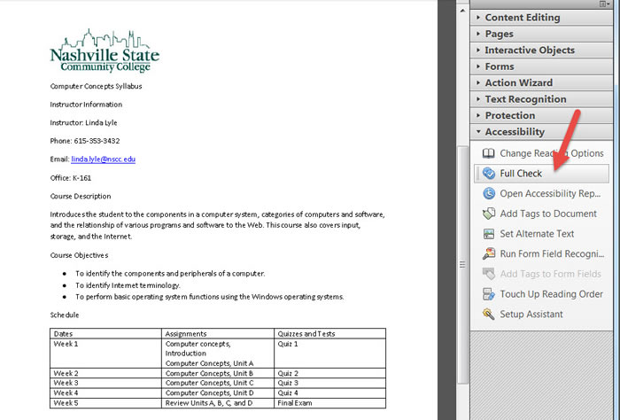
- When the dialog box opens, click the 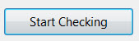button.
- Ensure that the Accessibility Report icon is selected at the left side of the screen. Accessibility issues will be reported. Click the plus symbol (+) next to “document (3 issues) in the left frame to expand the list. The document shown below has one failed item, the title flagged with a red icon; two items that are to be manually checked, marked with blue icons; and several accessible items, marked with green check marks.
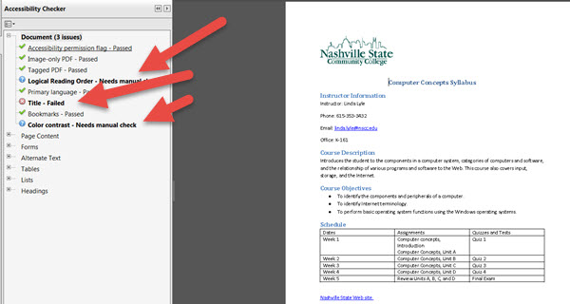

3. Run the Make Accessible Wizard
- Click on the Action Wizard group button on the Toolbar at the right and select Make Accessible.
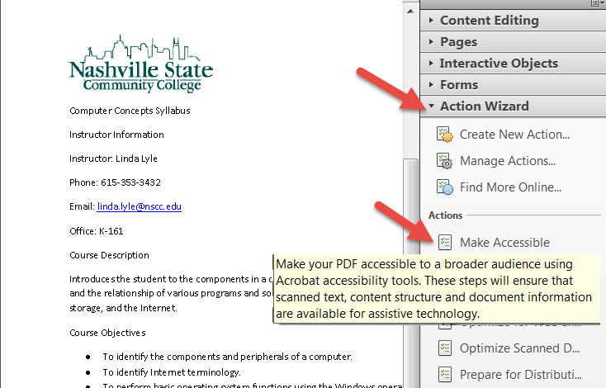
- Click on Start. This begins a three-step process: Prepare, Set Language & Tags, and Run Accessibility Check. Click on Start.
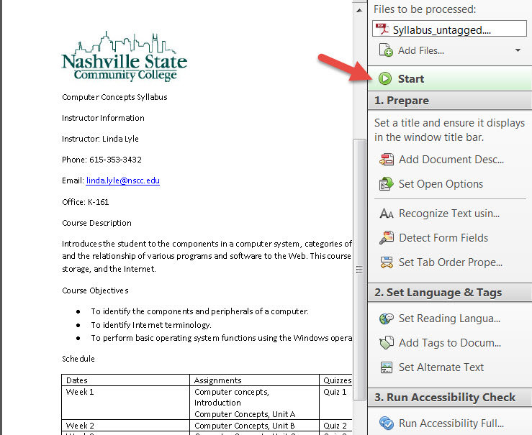
- Respond to each item as follows:
  - Ensure that “leave as is” next to Title is unchecked. Enter a title such as “Syllabus.” Click OK.
  - Click OK to recognize text settings.
  - For Form Fill, click on “No, Skip this Step.”
  - Choose OK to English.
  - Click OK to display figures with missing alt text. If notified of missing alt text, provide a short description. Click on OK. OK.
  - After updating each item, click on Start Checking to run the accessibility checker again.
- Close the Make Accessible window.

4. Check Reported Items Manually
An updated report will run as the last step of the Accessibility Wizard. Bold identifies areas of concern. In the report below there are two areas that need manual checking: Logical Reading Order and Color Contrast.
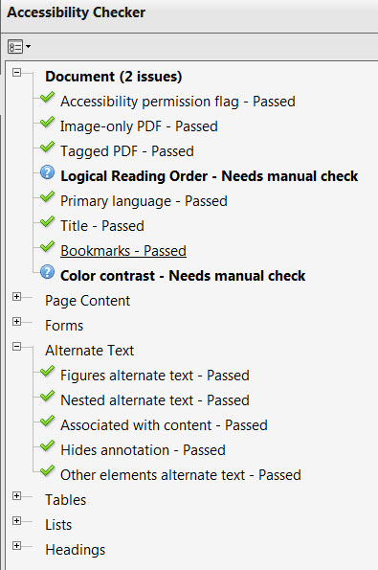

Manually Check Reading Order
Manually Checking Reading Order ensures that the document will be read in the order it is displayed on the page. Review each page of the document.

To manually check reading order,
- Click on Touch Up Reading Order under the Accessibility group.
- Ensure that "Page content order" is checked.
- “Show table cells,” “Display like elements in a single block,” “and Show tables and figures” are unchecked.
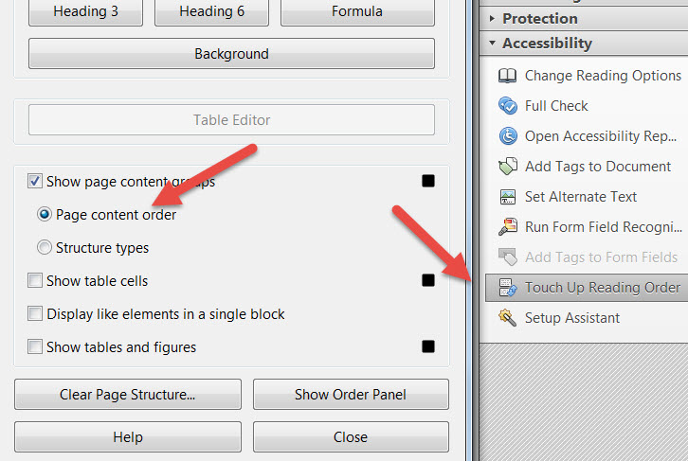
- Click the “Show Order Panel” button.
- Close.
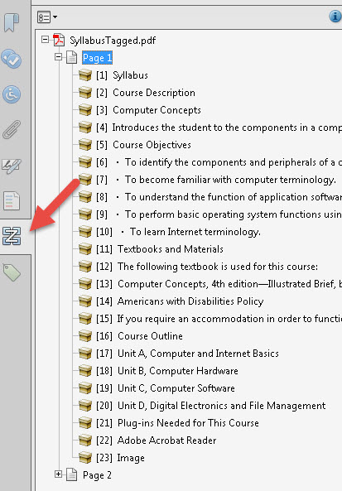
- Note, in the illustration below, that the image is read as Item 23. On your page, it will be 24. Usually images are out of order appearing at the end of the list. If that occurs, from the Order Panel at the left, click and drag the image or any item out of reading order to the correct location in the Order panel.
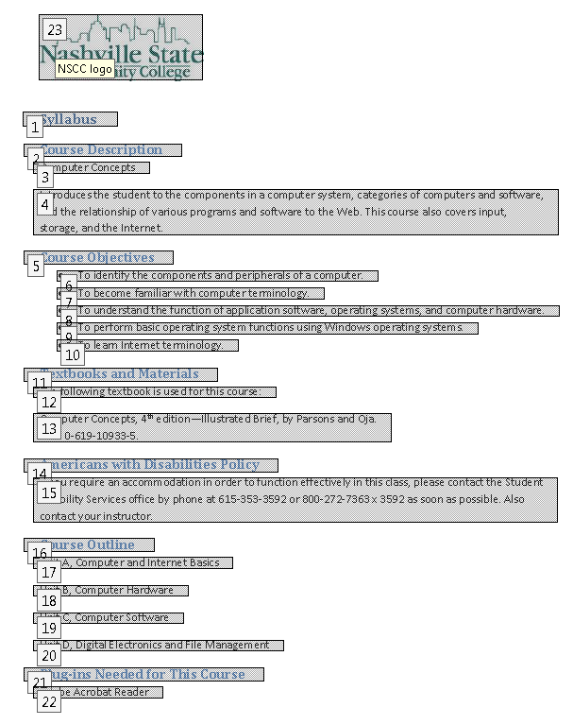

Manually Check Color Contrast
Color contrast refers to the intensity of color in the background and the foreground (or font). When you manually check and see colors that are potentially problematic,
- Choose Edit > Preferences (Windows) or Acrobat > Preferences (Mac OS).
- Click Accessibility.
- Select Replace Document Colors;
- Select Use High-Contrast Colors. Choose the color combination that you want from the pop-up menu.
- Click on OK.

5. Check Other Items Manually

Check Data Tables
If you have a data table, check for Table Headers even if they are not identified as an accessibility issue.
To check data tables,
- Go to the page that has a table.
- Click the Touch Up Reading Order Panel from the right window under Accessibility.
- Right-click inside the table area and select Table Editor. Right-click again in the table and choose Table Editor Options. Select the checkbox to “Show cell type (TH or TD).” Click on OK.The header cells should display <th>, and the data cells should display <td>.
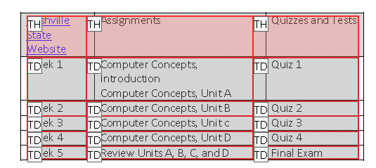
- If the data calls do not show TH for the header cells, select cells that should be the header (this could be the top row or the left column). A blue border surrounds the selected cells. Right-click and select Table Cell Properties. Choose Header Cell from the dialog box. You may choose the appropriate scope if desired. Click on OK.

Check Links
- To check links, click on the Tags view icon at the left of the screen.
- The out-of-the-box Adobe installation does not display the Tags panel. Right-click in the vertical bar to the far left of the screen and select “Tags.” You should need to do this only once.
- Click the plus symbol to expand the paragraph that contains the link. Ctrl + click expands all of the tags; Option + click on the Mac. Look for a tag named <Link>. The parent is "Link" followed by Link - OBJR then a span tag then the words of the link. Link - OBJR is required for keyboard accessibility.
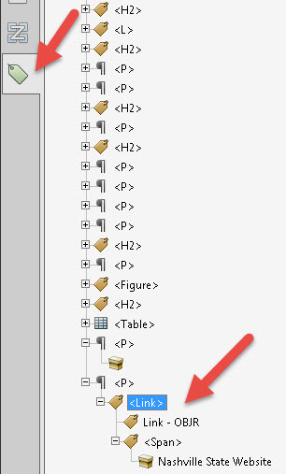
Either of the two following arrangements are also keyboard accessible.
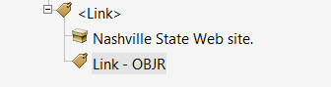
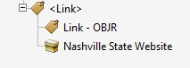

Additional Resources
Creating Accessible PDF’s (opens in a new window) with Chad Chelius from the lynda.com website. Login required. NSCC faculty and students have access to the lynda.com training videos. The training addresses accessibility, generating an accessible PDF file from Word, creating an accessible PDF from InDesign, and making an existing PDF file accessible. The last video suggests that the PAC Checker: http://www.pdfa.org/commercial/pdf-accessibility-checker-2-0-pac-2,/ (freeware) is a much more robust checker for PDF.
WebAIM PDF Accessibility (opens in a new window) This is an excellent document outlining accessibility features of Acrobat X and XI.
Creating In-Design Pages in Accessible Format (opens in new window) For users who use In-Design to create PDF files, this 39-minute video may be helpful.
Creating Accessible PDF Tutorials by VHA Section 508 Office (opens in a new window). This is a detailed tutorial for creating accessible PDF documents.
Acrobat XI Pro Accessibility Guide (opens in a new window) This is a very detailed documentation of the accessibility option in Acrobat XI Pro.

